F-CLASS TOLIMOJO ŠAUDYMO VARŽYBOS
„ AUKSINĖ KULKA 2016“
LOCATION : VOLLIT SHOOTING CENTER, Strazdai, Šiaulių region.
TIME AND PLACE: 2016 m. November 6-th, 10.00 a.m.
OPENING CEREMONY: 2016 m. November 6-th, 9.30 a.m.
WEIGHING AND SAFETY JOURNAL: November 6-th 8.00-9.15 a.m.
REGISTRATION AND INFORMATION: Advance registration will take place until 2016 November 4-th through www.vollit.lt The payment should be made to VšĮ "VOLLIT šaudymo centras“ acccount LT92 4010 0442 0108 2112 LTL, DNB bank, bank code 40100. In the payment description please write: Payment for the shooting competition “Auksinė kulka 2016“.
If registering after 4-th of November, the fee will be doubled.
The registration will be canceled when 54 participants register.
Participants who will be using muzzle brakes during the competition, please, inform us by e-mail info@vollit.lt and biuras@vollit.lt
TRAININGS: All competition participants will have a chanse to participate in the training before the competition on 5-th of November 2016 from 12:00 to 18:00. The time must be agreed on in advance. Price for the training 5 Eur/1h + targets.
STARTING FEE: 40,00 euro
SHOOTING ORDER: Shooting order will be determined randomly.
Shooting distances: 300 m , 500 m , 660 m.
Targets: Targets with X field thats meassurements are : 1 inch (2,54 cm) - 300 m target,
1,5 inch -500 m target and 2 inches -660 m target. Targets are divided into zones from 10 to 5 points with X in the midle of the target. With meassurements of 30cm zone for 300m target, 45cm for 500m and 60cm for 600m target. Any shot outside of the 5 zone will be counted as zero.

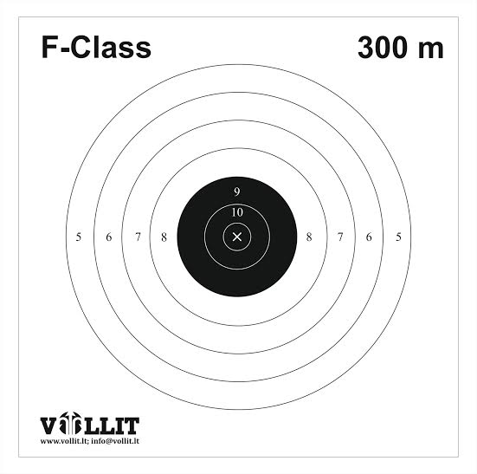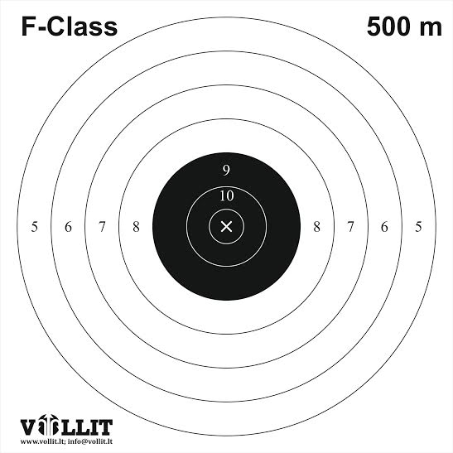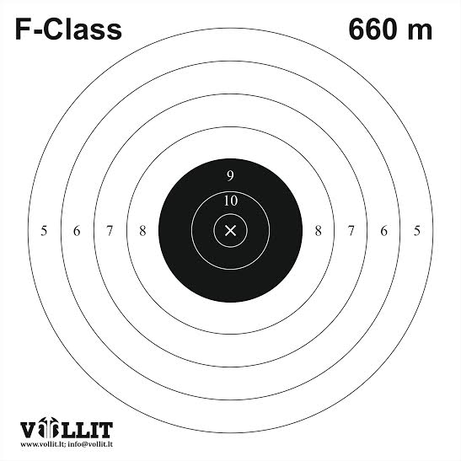

Shooting : Each participant will have 3 test shots and 15 for result for each distance.

F/TR class:
Shooting possition: laying down with a possibility to use one or two rests that are not connected together.
Front rest – shooting legs, back rest – shooting bag. The shoulder of the shooter must touch the recoil pad at every time.
Weapom: caliber 223 Rem or 308Win, the weight can‘t go over 8.25kg including the bipod and the riflescope. The rifle is loaded with single cartridge, the magazine can‘t be used. There are no limitations for riflescopes
OPEN klasė:
Šaudymo pozicija: laying down with a possibility to use one or two rests that are not connected together.
Front rest – shooting legs, back rest – shooting bag. The shoulder of the shooter must touch the recoil pad at every time.
.
Ginklas: The rifle can‘t have a caliber bigger that 8mm, the total weight cant go over 10kg. The rifle is loaded with single cartridge, the magazine can‘t be used. There are no limitations for riflescopes

Shooting procedure:
- The participant, after the referee‘s command „Take out your weapons“ has 4 minutes to take his shooting possition and place the rifle.
- After the referee‘s command „fire“ there will be 3 minutes time for 3 test shots.
- After the referee‘s command „stop“ the participant must stop shooting, stand up and move away from their rifles until referee‘s will mark the targets and the command „back to the shooting possitions“ will be given.
- The participant has 2 minutes time for riflescope corrections.
- After the referee‘s command „fire“ the shooting for points starts. The time limit will be 12 min, after that the participants will hear a command „stop“ that will mean that the shooting is over.
- In his possition the shooter can only have the needed ammount of cartridges 18pcs (3 for test shots and 15 for regular shots).

AWARDS:
- F/TR klass:
- For each distance, the participants who will be on the 1st to 6th place will receive a diploma. 1st to 3rd will receive medals.
- For the overall 1st to 3rd place winners will be awarded with competition Cups.
- OPEN klass:
- For each distance, the participants who will be on the 1st to 6th place will receive a diploma. 1st to 3rd will receive medals;
- For the overall 1st to 3rd place winners will be awarded with competition Cups.
- A participant with the best shot group in all distances will be awarded with a special prize.
- There will be a lotery after the award ceremony.
- All the participants of the competition will be offered some complementary tea and coffee. Uzbek pilaf will be offered as a meal for all participants.
- If you have any questions, please, do not hesitate to contact Gubtaytas +370 687 56534, or gintas@vollit.lt.

